Practical # 2
Design and implement a CI/CD pipeline using GitHub Actions that performs the complete deployment of the above system.
m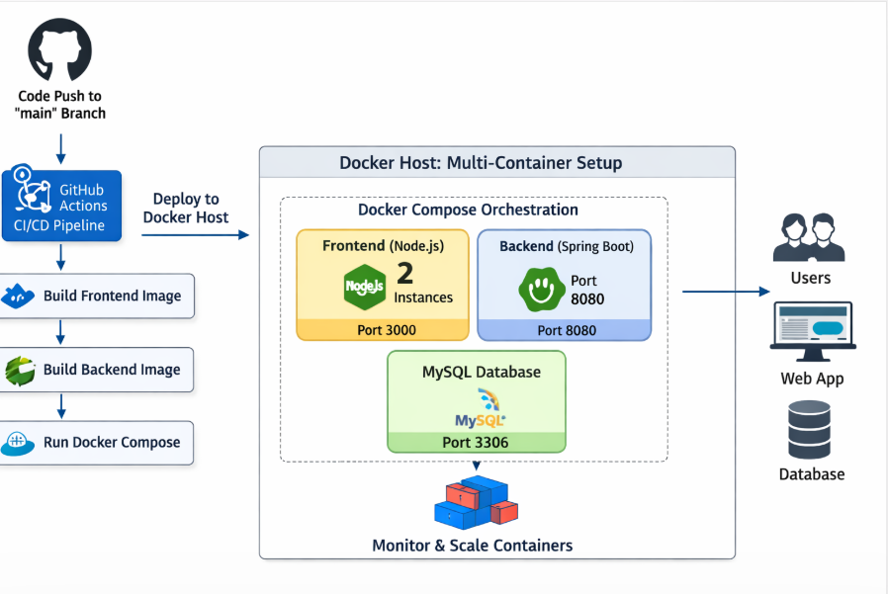

solutions:
Implemented Steps
Step 1: Create a GitHub Repository
First, a new GitHub repository was created to store the application source code, Dockerfile, and GitHub Actions workflow files. The repository acts as the central platform for version control and CI/CD automation.
The project files including:
- Application source code
- pom.xml
- Dockerfile
- README.md
were uploaded to the repository.
Example repository structure:
project/
│
├── src/
├── pom.xml
├── Dockerfile
└── README.md
After uploading the project, the code was committed and pushed to GitHub.
Step 2: Create GitHub Actions Workflow Directory
GitHub Actions workflows must be stored inside a special directory named:
.github/workflows/
This directory was created inside the root of the project.
Example:
project/
│
├── .github/
│ └── workflows/
GitHub automatically detects workflow files stored inside this folder.
Step 3: Create Workflow YAML File
Inside the workflows directory, a workflow configuration file named:
ci.yml
was created.
Final location:
.github/workflows/ci.yml
This YAML file defines the complete CI/CD pipeline.
Step 4: Define Workflow Name
A workflow name was added at the top of the YAML file.
Example:
name: CI/CD Pipeline
This name appears inside the GitHub Actions tab during workflow execution.
Step 5: Configure Workflow Trigger
The workflow was configured to start automatically whenever code is pushed to the main branch.
Example configuration:
on:
push:
branches:
- main
Explanation:
- on specifies workflow trigger events
- push means workflow starts after code push
- main indicates the target branch
Whenever developers push new code to the main branch, GitHub automatically triggers the workflow.
Step 6: Create Job Definition
A job named build was created inside the workflow.
Example:
jobs:
build:
A job represents a collection of automated steps executed together.
Step 7: Configure GitHub-Hosted Runner
The workflow was configured to run on a GitHub-hosted Ubuntu virtual machine.
Example:
runs-on: ubuntu-latest
Explanation:
- runs-on specifies the execution environment
- ubuntu-latest provides a Linux-based virtual machine
The runner automatically executes all workflow commands.

Step 8: Checkout Repository Source Code
The workflow used the official checkout action to download repository source code into the runner.
Example:
- name: Checkout Repository
uses: actions/checkout@v4
Explanation:
- uses executes a reusable GitHub Action
- actions/checkout clones repository code
Without this step, workflow jobs cannot access project files.
Step 9: Setup Java Environment
Since the project uses Maven and Java, Java setup was required.
The official Java setup action was added.
Example:
- name: Setup Java
uses: actions/setup-java@v4
with:
java-version: '17'
Explanation:
- Installs Java 17
- Configures Java environment
- Enables Maven compilation
This ensures the runner has the correct Java version before building the project.
Step 10: Build Maven Application
The Maven build command was executed to compile the project, run tests, and package the application.
Example:
- name: Build Application
run: mvn clean install
Explanation:
- mvn clean removes old build files
- mvn install compiles and packages application
This step generates the final JAR/WAR file.
Generated files are stored inside:
target/
Step 11: Create Dockerfile
A Dockerfile was created in the project root directory to containerize the Maven application.
Example Dockerfile:
FROM openjdk:17

WORKDIR /app

COPY target/app.jar app.jar

ENTRYPOINT ["java","-jar","app.jar"]
Explanation:
- FROM defines base image
- WORKDIR sets working directory
- COPY copies JAR file
- ENTRYPOINT starts application
This Dockerfile is used to build Docker images automatically.

Step 12: Build Docker Image
The workflow was configured to build a Docker image using the Dockerfile.
Example:
- name: Build Docker Image
run: docker build -t myapp .
Explanation:
- docker build creates Docker image
- -t myapp assigns image name
- . specifies current directory
The application is now packaged inside a Docker container image.

Step 13: Configure GitHub Secrets
Sensitive credentials were securely stored using GitHub Secrets.
The following secrets were added:
Secret Name | Purpose
DOCKER_USERNAME | Docker Hub username
DOCKER_PASSWORD | Docker Hub password/token
Steps:
- Open GitHub Repository
- Go to Settings
- Select Secrets and Variables
- Add Actions Secrets
Secrets improve security because credentials are not written directly inside workflow files.
Step 14: Login to Docker Hub
The workflow used Docker login action for authentication.
Example:
- name: Login to Docker Hub
uses: docker/login-action@v3
with:
username: ${{ secrets.DOCKER_USERNAME }}
password: ${{ secrets.DOCKER_PASSWORD }}
Explanation:
- Authenticates Docker client
- Allows image push access
- Uses secure GitHub Secrets
Step 15: Push Docker Image to Docker Hub
After successful image build, the Docker image was pushed to Docker Hub registry.
Example:
- name: Push Docker Image
run: docker push myapp
Explanation:
- Uploads image to Docker Hub
- Makes image accessible globally
- Enables deployment from registry
The image can now be downloaded using:
docker pull myapp
Step 16: Commit and Push Workflow File
The workflow configuration file was committed and pushed to GitHub repository.
Commands used:
git add .
git commit -m "add GitHub Actions CI/CD workflow"
git push
Explanation:
- git add stages files
- git commit saves changes
- git push uploads files to GitHub
Pushing the workflow automatically triggered the CI/CD pipeline.
Step 17: Verify Workflow Execution
Workflow execution was verified from the GitHub Actions tab.
Navigation:
GitHub Repository → Actions
The following were checked:
- Build status
- Maven logs
- Docker build logs
- Docker push status
- Workflow success/failure
Successful workflow execution confirmed that the CI/CD pipeline was implemented correctly.

Step 18: Final Workflow Process
Complete pipeline flow:
Developer Pushes Code
↓
GitHub Actions Triggered
↓
Checkout Repository
↓
Setup Java Environment
↓
Build Maven Project
↓
Create Docker Image
↓
Login to Docker Hub
↓
Push Docker Image
↓
CI/CD Pipeline Completed

